Making a Motor Move

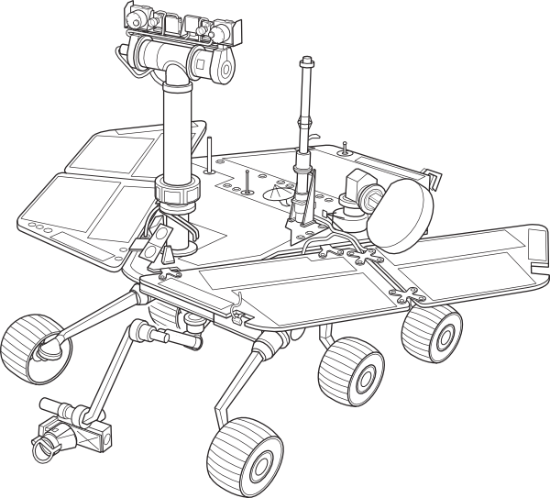
Task

- Create the circuit shown on next page
- Open the Arduino IDE program on your computer
- In the menu at the top of the arduino program go to
File → Examples → 03.Analog → Fading
- Upload code to arduino
- One Motor should speed up and slow down
- Change Code so both motors move.
HINT: You need to use the command analogWrite(ledPin2, fadeValue) and create a new variable ledPin2 with value 10 int ledPin2 = 10;

Extensions

- Use a sensor of your choice (for example a potentiometer) connect it up and use it to control the speed of the motor

Program Code: (File → Examples → 03.Analog → Fading)
int ledPin = 9; // Motor connected to digital pin 9

void setup() {
// nothing happens in setup
}

void loop() {
// fade in from min to max in increments of 5 points:
for(int fadeValue = 0 ; fadeValue <= 255; fadeValue +=5) {
// sets the value (range from 0 to 255):
analogWrite(ledPin, fadeValue);
// wait for 30 milliseconds to see the dimming effect
delay(30);
}

// fade out from max to min in increments of 5 points:
for(int fadeValue = 255 ; fadeValue >= 0; fadeValue -=5) {
// sets the value (range from 0 to 255):
analogWrite(ledPin, fadeValue);
// wait for 30 milliseconds to see the dimming effect
delay(30);
}
}

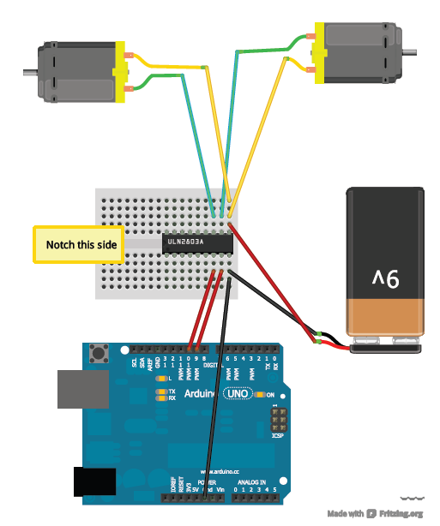
Pin 9 and Pin 10
Check with your helper as to what power source you need.
Must be the Red/positive lead of your battery
Must be the Grey/negative lead of your battery

